**Assignment 3**

**Group: DWDM19G04**

**Roll Numbers: 2016BTECS00063, 2016BTECS00081, 2016BTECS00103**

**Batch: B7**

**Date: 7th September, 2019**

**Title: Data Warehousing**

**Problem Statement:**

X-Mart is having different malls in our city, where daily sales take place for various products. We need to design Dimensional Model to suit requirements of users which must address business needs and contains information which can be easily accessible. Design of model should be easily extensible according to future needs. This model design must support OLAP cubes to provide "instantaneous" query results for analysts.

**Theory:**

**Dimension**  
The dimension is a master table composed of individual, non-overlapping data elements.  
The primary functions of dimensions are to provide filtering, grouping and labeling on your  
data. Dimension tables contain textual descriptions about the subjects of the business.

**Measure**  
A measure represents a column that contains quantifiable data, usually numeric, that can be aggregated. A measure is generally mapped to a column in a fact table.

**Fact Table**  
Data in fact table are called measures (or dependent attributes), Fact table provides  
statistics for sales broken down by customer, salesperson, product, period and store  
dimensions. Fact table usually contains historical transactional entries of your live system, it is mainly made up of Foreign key column which references to various dimension and  
numeric measure values on which aggregation will be performed. Fact tables are of  
different types, E.g. Transactional, Cumulative and Snapshot.

**Output:**

CREATE TABLE DIMCUSTOMER

(

CUSTOMERID INT PRIMARY KEY,

CUSTOMERALTID VARCHAR(10) NOT NULL,

CUSTOMERNAME VARCHAR(50),

GENDER VARCHAR(20)

);

INSERT INTO DIMCUSTOMER VALUES(1,'IMI-001','HENRY FORD','M');

INSERT INTO DIMCUSTOMER VALUES(2,'IMI-002','BILL GATES','M');

INSERT INTO DIMCUSTOMER VALUES(3,'IMI-003','MUSKAN SHAIKH','F');

INSERT INTO DIMCUSTOMER VALUES(4,'IMI-004','RICHARD THRUBIN','M');

INSERT INTO DIMCUSTOMER VALUES(5,'IMI-005','EMMA WATTSON','F');

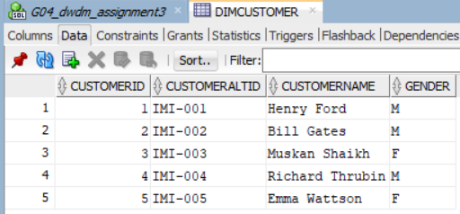

CREATE TABLE DIMPRODUCT

(

PRODUCTKEY INT PRIMARY KEY,

PRODUCTALTKEY VARCHAR(10)NOT NULL,

PRODUCTNAME VARCHAR(100),

PRODUCTACTUALCOST INT,

PRODUCTSALESCOST INT

)

INSERT INTO DIMPRODUCT VALUES (11,'ITM-001','WHEAT FLOOR 1KG',5.50,6.50);

INSERT INTO DIMPRODUCT VALUES (12,'ITM-002','RICE GRAINS 1KG',22.50,24);

INSERT INTO DIMPRODUCT VALUES (13,'ITM-003','SUNFLOWER OIL 1 LTR',42,43.5);

INSERT INTO DIMPRODUCT VALUES (14,'ITM-004','NIRMA SOAP',18,20);

INSERT INTO DIMPRODUCT VALUES (15,'ITM-005','ARIAL WASHING POWDER 1KG',135,139);

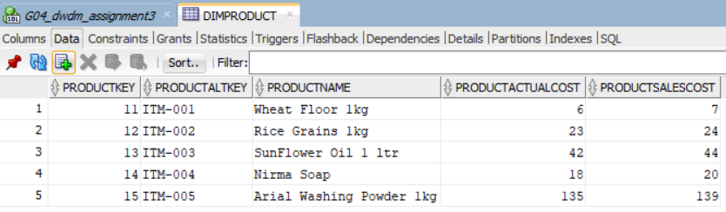

CREATE TABLE DIMSTORES

(

STOREID INT PRIMARY KEY,

STOREALTID VARCHAR(10)NOT NULL,

STORENAME VARCHAR(100),

STORELOCATION VARCHAR(100),

CITY VARCHAR(100),

STATE VARCHAR(100),

COUNTRY VARCHAR(100)

)

INSERT INTO DIMSTORES VALUES(111,'LOC-A1','X-MART','S.P. RINGROAD','AHMEDABAD','GUJ','INDIA');

INSERT INTO DIMSTORES VALUES(112,'LOC-A2','X-MART','MANINAGAR','AHMEDABAD','GUJ','INDIA');

INSERT INTO DIMSTORES VALUES(113,'LOC-A3','X-MART','SIVRANJANI','AHMEDABAD','GUJ','INDIA');

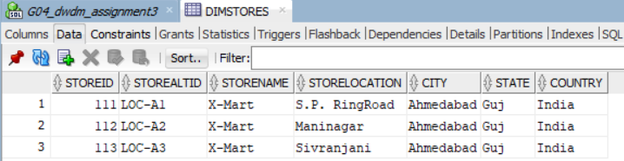

CREATE TABLE DIMSALESPERSON

(

SALESPERSONID INT PRIMARY KEY,

SALESPERSONALTID VARCHAR(10)NOT NULL,

SALESPERSONNAME VARCHAR(100),

STOREID INT,

CITY VARCHAR(100),

STATE VARCHAR(100),

COUNTRY VARCHAR(100)

)

INSERT INTO DIMSALESPERSON VALUES (1111,'SP-DMSPR1','ASHISH',1,'AHMEDABAD','GUJ','INDIA');

INSERT INTO DIMSALESPERSON VALUES (1112,'SP-DMSPR2','KETAN',1,'AHMEDABAD','GUJ','INDIA');

INSERT INTO DIMSALESPERSON VALUES (1113,'SP-DMNGR1','SRINIVAS',2,'AHMEDABAD','GUJ','INDIA');

INSERT INTO DIMSALESPERSON VALUES (1114,'SP-DMNGR2','SAAD',2,'AHMEDABAD','GUJ','INDIA');

INSERT INTO DIMSALESPERSON VALUES (1115,'SP-DMSVR1','JASMIN',3,'AHMEDABAD','GUJ','INDIA');

INSERT INTO DIMSALESPERSON VALUES (1116,'SP-DMSVR2','JACOB',3,'AHMEDABAD','GUJ','INDIA');

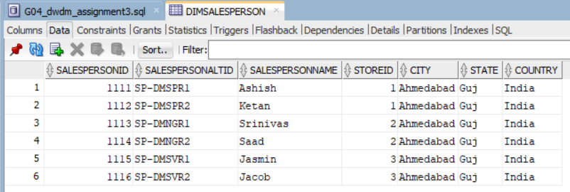

CREATE TABLE DIMTIME(

TIMEKEY INT NOT NULL,

TIMEALTKEY INT NOT NULL,

TIME30 VARCHAR(8) NOT NULL,

HOUR30 INT NOT NULL,

MINUTENUMBER INT NOT NULL,

SECONDNUMBER INT NOT NULL,

TIMEINSECOND INT NOT NULL,

HOURLYBUCKET VARCHAR(15)NOT NULL,

DAYTIMEBUCKETGROUPKEY INT NOT NULL,

DAYTIMEBUCKET VARCHAR(100) NOT NULL

);

INSERT INTO DIMTIME (TIMEKEY,TIMEALTKEY, TIME30,HOUR30,MINUTENUMBER, SECONDNUMBER, TIMEINSECOND,HOURLYBUCKET, DAYTIMEBUCKETGROUPKEY,DAYTIMEBUCKET)

VALUES(1,30000,'3:00:00',3,00,00,10800,'3:00-3:59',1,'EARLY MORNING(03:00 AM TO 6:59 AM)');

INSERT INTO DIMTIME (TIMEKEY,TIMEALTKEY, TIME30,HOUR30,MINUTENUMBER, SECONDNUMBER, TIMEINSECOND,HOURLYBUCKET, DAYTIMEBUCKETGROUPKEY,DAYTIMEBUCKET)

VALUES(2,121000,'12:10:00',12,10,00,43800,'12:00-12:59',4,'LUNCH (12:00 PM TO 13:59 PM)');

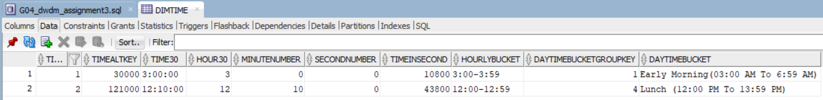

CREATE TABLE FACTPRODUCTSALES

(

TRANSACTIONID INT PRIMARY KEY,

SALESINVOICENUMBER INT NOT NULL,

SALESDATEKEY INT,

SALESTIMEKEY INT,

SALESTIMEALTKEY INT,

STOREID INT NOT NULL,

CUSTOMERID INT NOT NULL,

PRODUCTID INT NOT NULL,

SALESPERSONID INT NOT NULL,

QUANTITY FLOAT,

SALESTOTALCOST INT,

PRODUCTACTUALCOST INT,

DEVIATION FLOAT

)

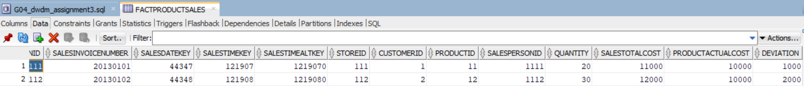

ALTER TABLE FACTPRODUCTSALES ADD

FOREIGN KEY(STOREID)REFERENCES DIMSTORES(STOREID);

ALTER TABLE FACTPRODUCTSALES ADD

FOREIGN KEY (CUSTOMERID)REFERENCES DIMCUSTOMER(CUSTOMERID);

ALTER TABLE FACTPRODUCTSALES ADD

FOREIGN KEY (PRODUCTID)REFERENCES DIMPRODUCT(PRODUCTKEY);

ALTER TABLE FACTPRODUCTSALES ADD

FOREIGN KEY (SALESPERSONID)REFERENCES DIMSALESPERSON(SALESPERSONID);

--ALTER TABLE FACTPRODUCTSALES ADD

--FOREIGN KEY (SALESTIMEKEY)REFERENCES DIMDATE(TIMEKEY);

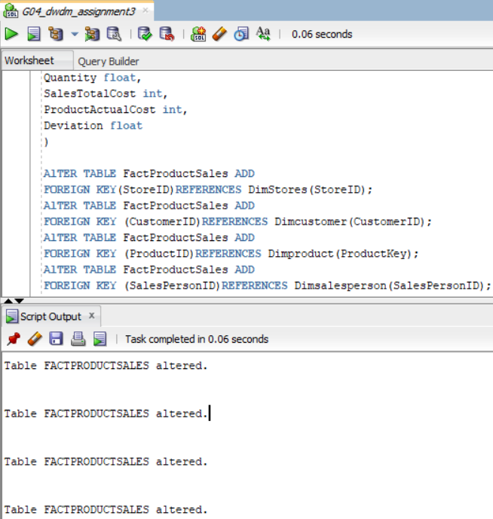

INSERT INTO FACTPRODUCTSALES VALUES(11111,20130101,44347,121907,1219070,111,1,11,1111,20,11000,10000,1000);

INSERT INTO FACTPRODUCTSALES VALUES(11112,20130102,44348,121908,1219080,112,2,12,1112,30,12000,10000,2000);

**Conclusion**:

We learnt how to design Model to suit requirements of users which addresses business needs and contains information which can be easily accessible. This model design supports OLAP cubes to provide "instantaneous" query results for analysts.